

Practical File Submission
Course Name: JavaScript Lab
Course Code: T-3013 / 0705210508
Submitted by
Insiya Hussain
24070521156
Batch: 2024-28
Semester - V
Section: C

Submitted to
Dr. Shreyas Rajendra Hole

Practical 1
Experiment Title: Demonstrate inline, internal, and external JavaScript; use console methods; create a webpage showing user info and a welcome message.
Software/Tools Required: VS Code , Web Browser
Experiment Program Code:
Demo html file:

<!DOCTYPE html>
<html lang="en">
<head>
<meta charset="UTF-8">
<meta name="viewport" content="width=device-width, initial-scale=1.0">

<title>JavaScript Experiment 1</title>

<style>

body{
margin:0;
padding:30px;
background:#f5f5f5;
font-family:Arial, Helvetica, sans-serif;
}

h1{
text-align:center;
color:#333;
margin-bottom:35px;
}

.container{
width:70%;
margin:auto;
}

.card{

background:#b39ddb;

color:white;

text-align:center;

padding:25px;

margin-bottom:25px;

border-radius:10px;

box-shadow:0 3px 8px rgba(0,0,0,0.2);

transition:0.3s;
}

.card:hover{

transform:translateY(-3px);
}

.card h2{

margin-bottom:15px;
}

.card p{

margin:8px;
font-size:16px;
}

button{

margin-top:15px;

padding:10px 20px;

border:none;

border-radius:5px;

background:white;

color:#6a1b9a;

cursor:pointer;

font-weight:bold;
}

button:hover{

background:#eeeeee;
}

.footer{

text-align:center;

margin-top:25px;

color:#666;

font-size:14px;
}

</style>

</head>

<body>

<h1>JavaScript Experiment - 1</h1>

<div class="container">

<div class="card">

<h2>Welcome to Inline JavaScript</h2>

<p><strong>Name :</strong> INSIYA HUSSAIN</p>

<p><strong>PRN :</strong> 24070521156 </p>

<button onclick="alert('Welcome to Inline JavaScript!')">
Click Here
</button>

</div>

<div class="card">

<h2>Welcome to Internal JavaScript</h2>

<p><strong>Name :</strong> INSIYA HUSSAIN</p>

<p><strong>PRN :</strong> 24070521156 </p>

<button onclick="internalJS()">
Click Here
</button>

</div>

<div class="card">

<h2>Welcome to External JavaScript</h2>

<p><strong>Name :</strong> INSIYA HUSSAIN</p>

<p><strong>PRN :</strong> 24070521156 </p>

<button onclick="externalJS()">
Click Here
</button>

</div>

</div>

<div class="footer">
JavaScript Lab Experiment 1

</div>

<script>

console.log("Console Log Example");
console.info("Console Info Example");
console.warn("Console Warning Example");
console.error("Console Error Example");

function internalJS(){

alert("Welcome to Internal JavaScript!");

}

function externalJS(){

alert("Welcome to External JavaScript!");

}

</script>

</body>
</html>

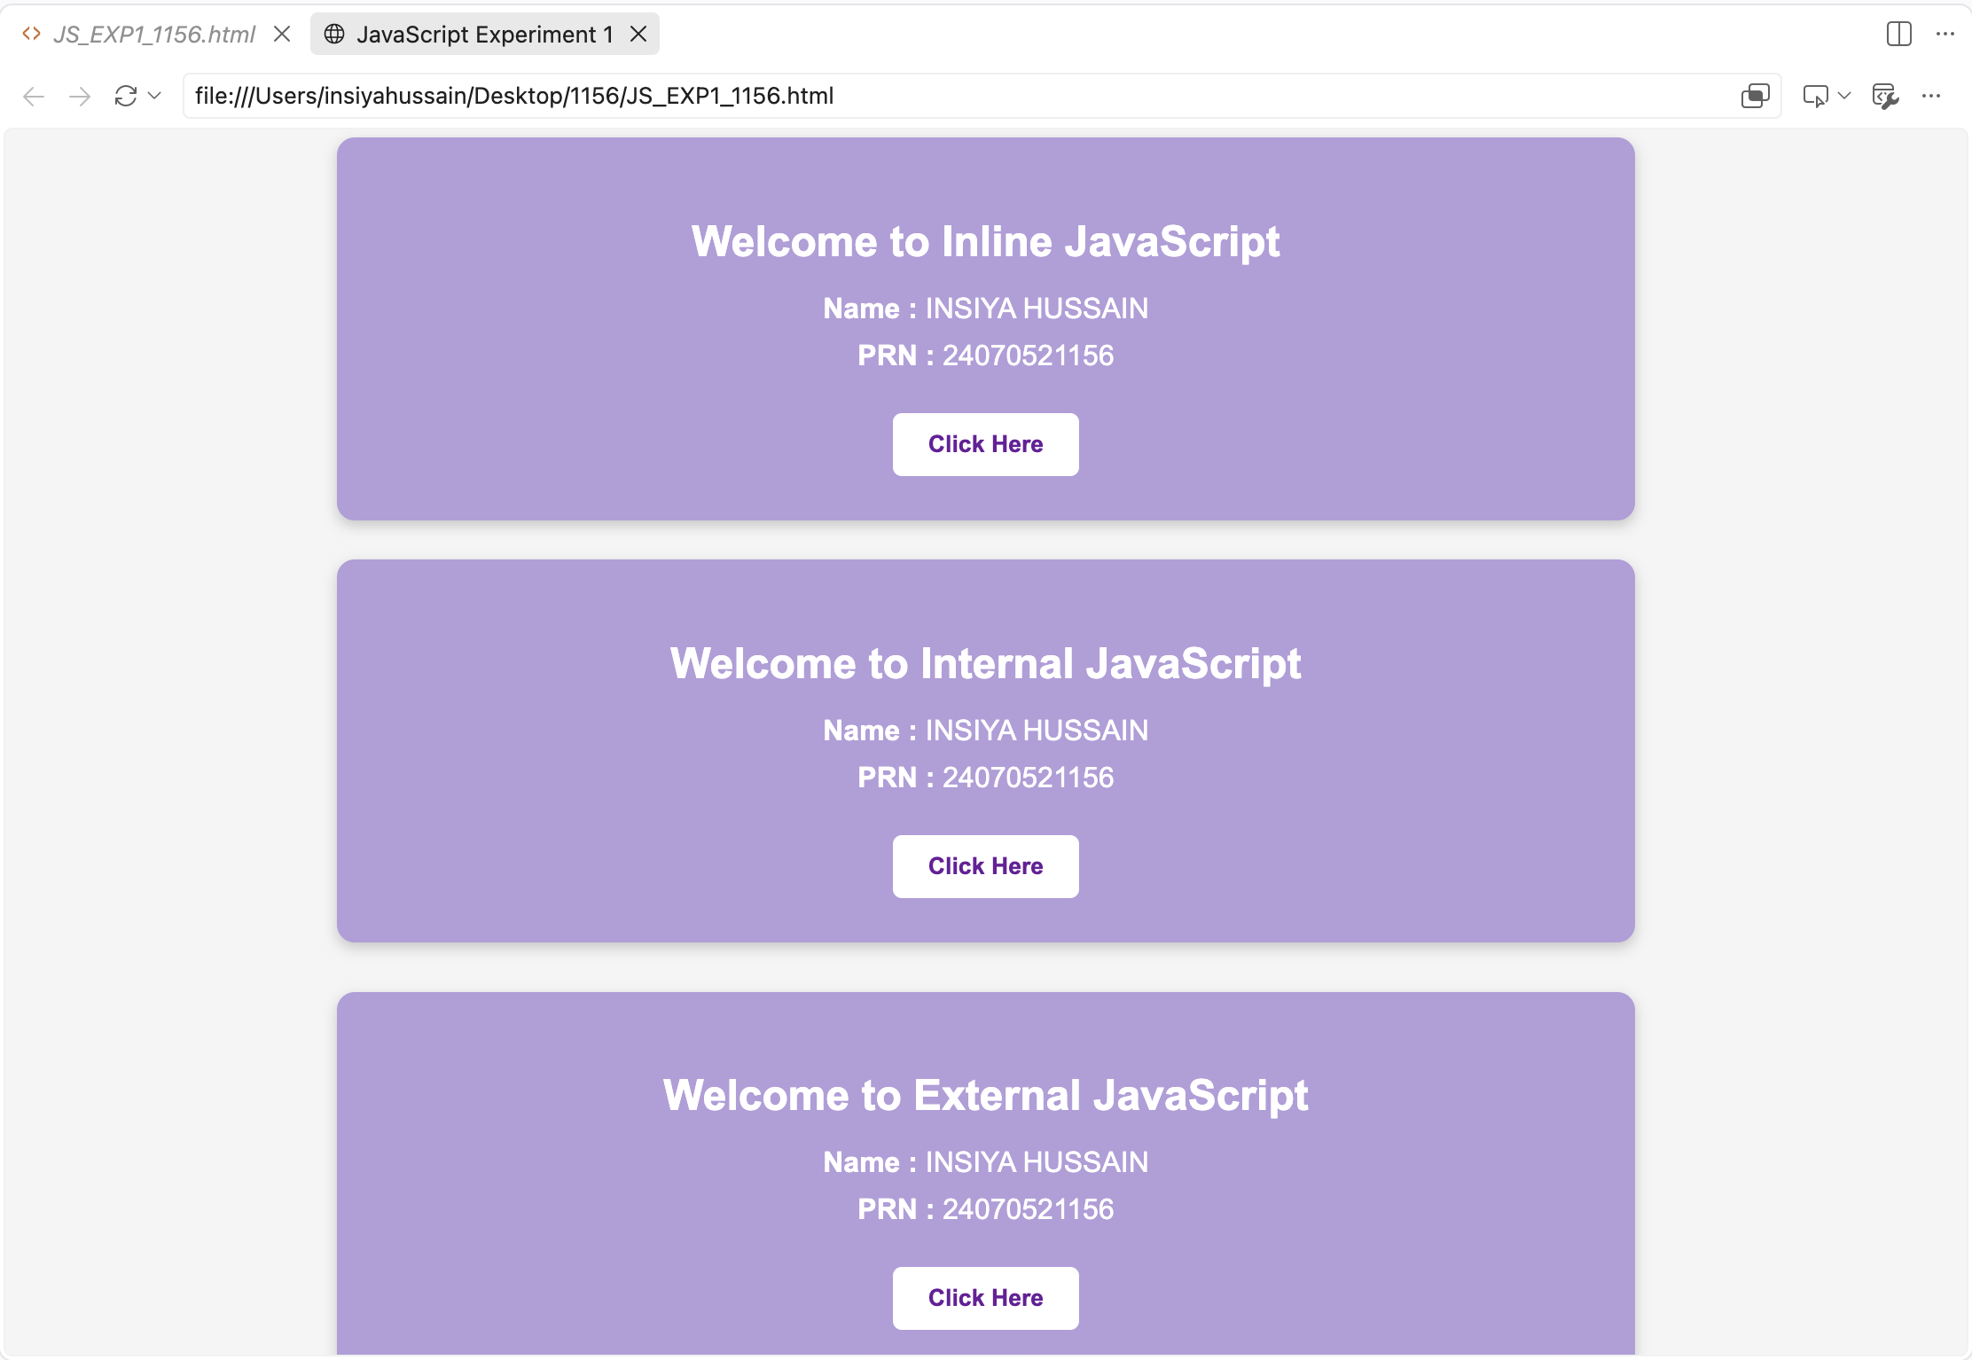
Output:

Case Study 01
Case Study Title:- Create a web page for college department and link the student information page with it and write a js program to display "Welcome to SIT Nagpur" in an alert box
Case Study Code:
<!DOCTYPE html>
<html>
<head>
<title>Department - PRN 1156</title>

<script>
window.onload = function () {
alert("Welcome to SIT Nagpur");
}

function showStudent() {
document.getElementById("student").style.display = "block";
}
</script>
</head>

<body bgcolor="white">

<h1 align="center">Symbiosis Institute of Technology, Nagpur</h1>

<h2>Computer Science & Engineering Department</h2>

<p>
Welcome to the Computer Science & Engineering Department.
We offer courses in Programming, Data Science and AI.
</p>

<button onclick="showStudent()">Student Information</button>

<div id="student" style="display:none; margin-top:20px;">

<h3>Student Information</h3>

<table border="1" cellpadding="8">
<tr>
<th>PRN</th>
<th>Name</th>

<th>Department</th>
</tr>

<tr>

<td>1156</td>
<td>Your Name</td>
<td>Data Science</td>
</tr>

</table>
</div>
</body>
</html>

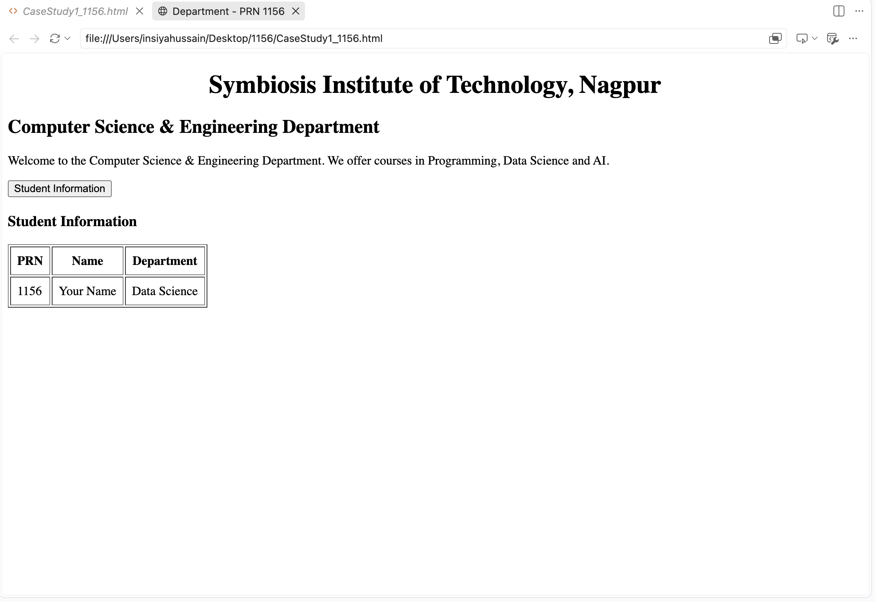
Output:

Practical 02
Aim:- Use var, let, const, and demonstrate basic features like template literals and destructuring; build a billing calculator with user input.
Software/Tools Required: VS Code , Web Browser
Experiment program code:
<!DOCTYPE html>
<html lang="en">
<head>
<meta charset="UTF-8">
<meta name="viewport" content="width=device-width, initial-scale=1.0">
<title>Experiment 2 - Billing Calculator</title>

<style>
body{
font-family: Arial, sans-serif;
background:#f2f4f8;
margin:0;
padding:40px;
}

.container{
width:420px;
margin:auto;
background:white;
padding:25px;
border-radius:10px;
box-shadow:0 0 10px rgba(0,0,0,0.2);
}

h2{
text-align:center;
color:#2c3e50;
}

label{
display:block;
margin-top:15px;
font-weight:bold;
}

input{
width:100%;

padding:10px;
margin-top:5px;
border:1px solid #ccc;

border-radius:5px;
box-sizing:border-box;
}

button{
width:100%;
margin-top:20px;
padding:12px;
background:#3498db;
color:white;
border:none;
border-radius:5px;
cursor:pointer;
font-size:16px;
}

button:hover{
background:#2980b9;
}

#result{
margin-top:20px;
background:#eef7ff;
padding:15px;
border-radius:8px;
line-height:1.8;
}
</style>

</head>
<body>

<div class="container">

<h2>Billing Calculator</h2>

<label>Customer Name</label>
<input type="text" id="name" placeholder="Enter customer name">

<label>Product Name</label>
<input type="text" id="product" placeholder="Enter product">

<label>Price (₹)</label>
<input type="number" id="price" placeholder="Enter price">

<label>Quantity</label>
<input type="number" id="quantity" placeholder="Enter quantity">

<button onclick="calculateBill()">Generate Bill</button>

<div id="result"></div>

</div>

<script>

var gstRate = 18;

// const example
const shopName = "ABC Super Store";

function calculateBill(){

let customer = document.getElementById("name").value;
let product = document.getElementById("product").value;
let price = Number(document.getElementById("price").value);
let quantity = Number(document.getElementById("quantity").value);

if(customer=="" || product=="" || price<=0 || quantity<=0){
alert("Please enter valid details.");
return;
}

let amount = price * quantity;
let gst = amount * gstRate / 100;
let total = amount + gst;

const bill = {
customer,
product,
amount,

gst,
total
};

const {customer: cname, product: pname, amount: amt, gst: tax, total: finalTotal} = bill;

// Template Literals
document.getElementById("result").innerHTML = `
<h3>Bill Receipt</h3>
<b>Shop:</b> ${shopName}<br>
<b>Customer:</b> ${cname}<br>
<b>Product:</b> ${pname}<br>
<b>Amount:</b> ₹${amt.toFixed(2)}<br>
<b>GST (18%):</b> ₹${tax.toFixed(2)}<br>
<hr>
<h3>Total Bill: ₹${finalTotal.toFixed(2)}</h3>
`;
}

</script>
</body>
</html>
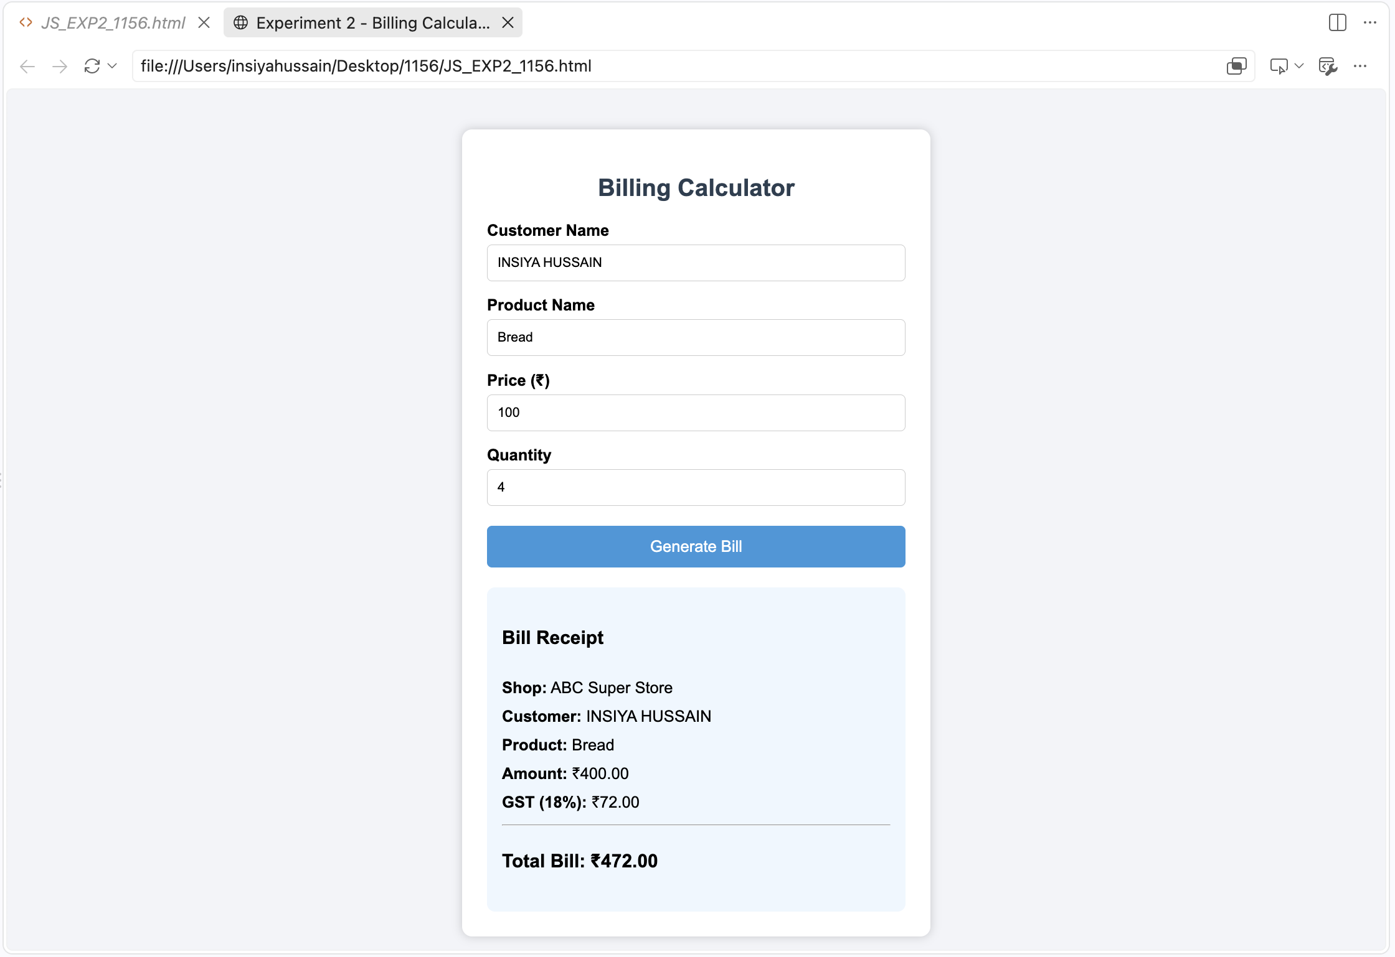
Output:-

Case Study 02
Case Study Title:- Develop the webpage for an online shopping website with using HTML,CSS and HTML5 tags
Software/Tools Used:- VScode , Web Browser
Code:-
<!DOCTYPE html>
<html>
<head>
<title>Online Shopping Bill - PRN 1156</title>

<style>
body{
font-family: Arial;
background:#f2f2f2;
}
.container{
width:450px;
margin:auto;
background:white;
padding:20px;
border-radius:8px;
}
h2{
text-align:center;
}
input,select{
width:100%;
padding:6px;
margin:5px 0;
}
button{
width:100%;
padding:8px;
background:green;
color:white;
border:none;
}
#result{
margin-top:20px;
background:#eef;
padding:10px;

}
</style>

<script>
function bill(){

var cname=document.getElementById("cname").value;
var mobile=document.getElementById("mobile").value;
var invoice=document.getElementById("invoice").value;
var product=document.getElementById("product").value;
var qty=parseFloat(document.getElementById("qty").value);
var rate=parseFloat(document.getElementById("rate").value);
var payment=document.getElementById("payment").value;
var member=document.getElementById("member").value;

var amount=qty*rate;
var discount=(member=="Yes")?amount*0.10:0;
var gst=(amount-discount)*0.05;
var packing=30;
var total=amount-discount+gst+packing;

document.getElementById("result").innerHTML=
"<h3>Invoice</h3>"+
"Customer Name : "+cname+"<br>"+
"Mobile : "+mobile+"<br>"+
"Invoice No : "+invoice+"<br>"+
"Product Name : "+product+"<br>"+
"Quantity : "+qty+" kg<br>"+
"Rate : ₹"+rate+"<br>"+
"Amount : ₹"+amount.toFixed(2)+"<br>"+
"Discount : ₹"+discount.toFixed(2)+"<br>"+
"GST (5%) : ₹"+gst.toFixed(2)+"<br>"+
"Packing Charges : ₹30<br>"+
"Payment Mode : "+payment+"<br>"+
"Membership : "+member+"<br><hr>"+
"<b>Total Bill : ₹"+total.toFixed(2)+"</b>";
}
</script>

</head>

<body>

<div class="container">

<h2>Online Shopping Billing System</h2>

Customer Name
<input type="text" id="cname">

Mobile Number
<input type="text" id="mobile">

Invoice Number
<input type="text" id="invoice">

Product Name
<input type="text" id="product">

Quantity (kg)
<input type="number" id="qty">

Rate per kg
<input type="number" id="rate">

Payment Mode
<select id="payment">
<option>Cash</option>
<option>Card</option>
<option>UPI</option>
</select>

Membership
<select id="member">
<option>Yes</option>
<option>No</option>
</select>

<button onclick="bill()">Calculate Bill</button>

<div id="result"></div>

</div>
</body>
</html>

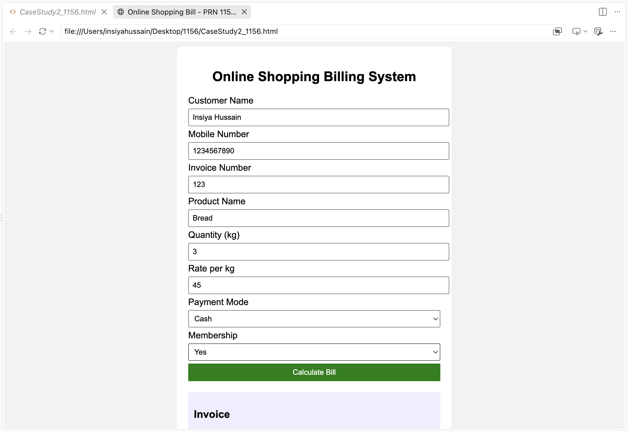
Output:-

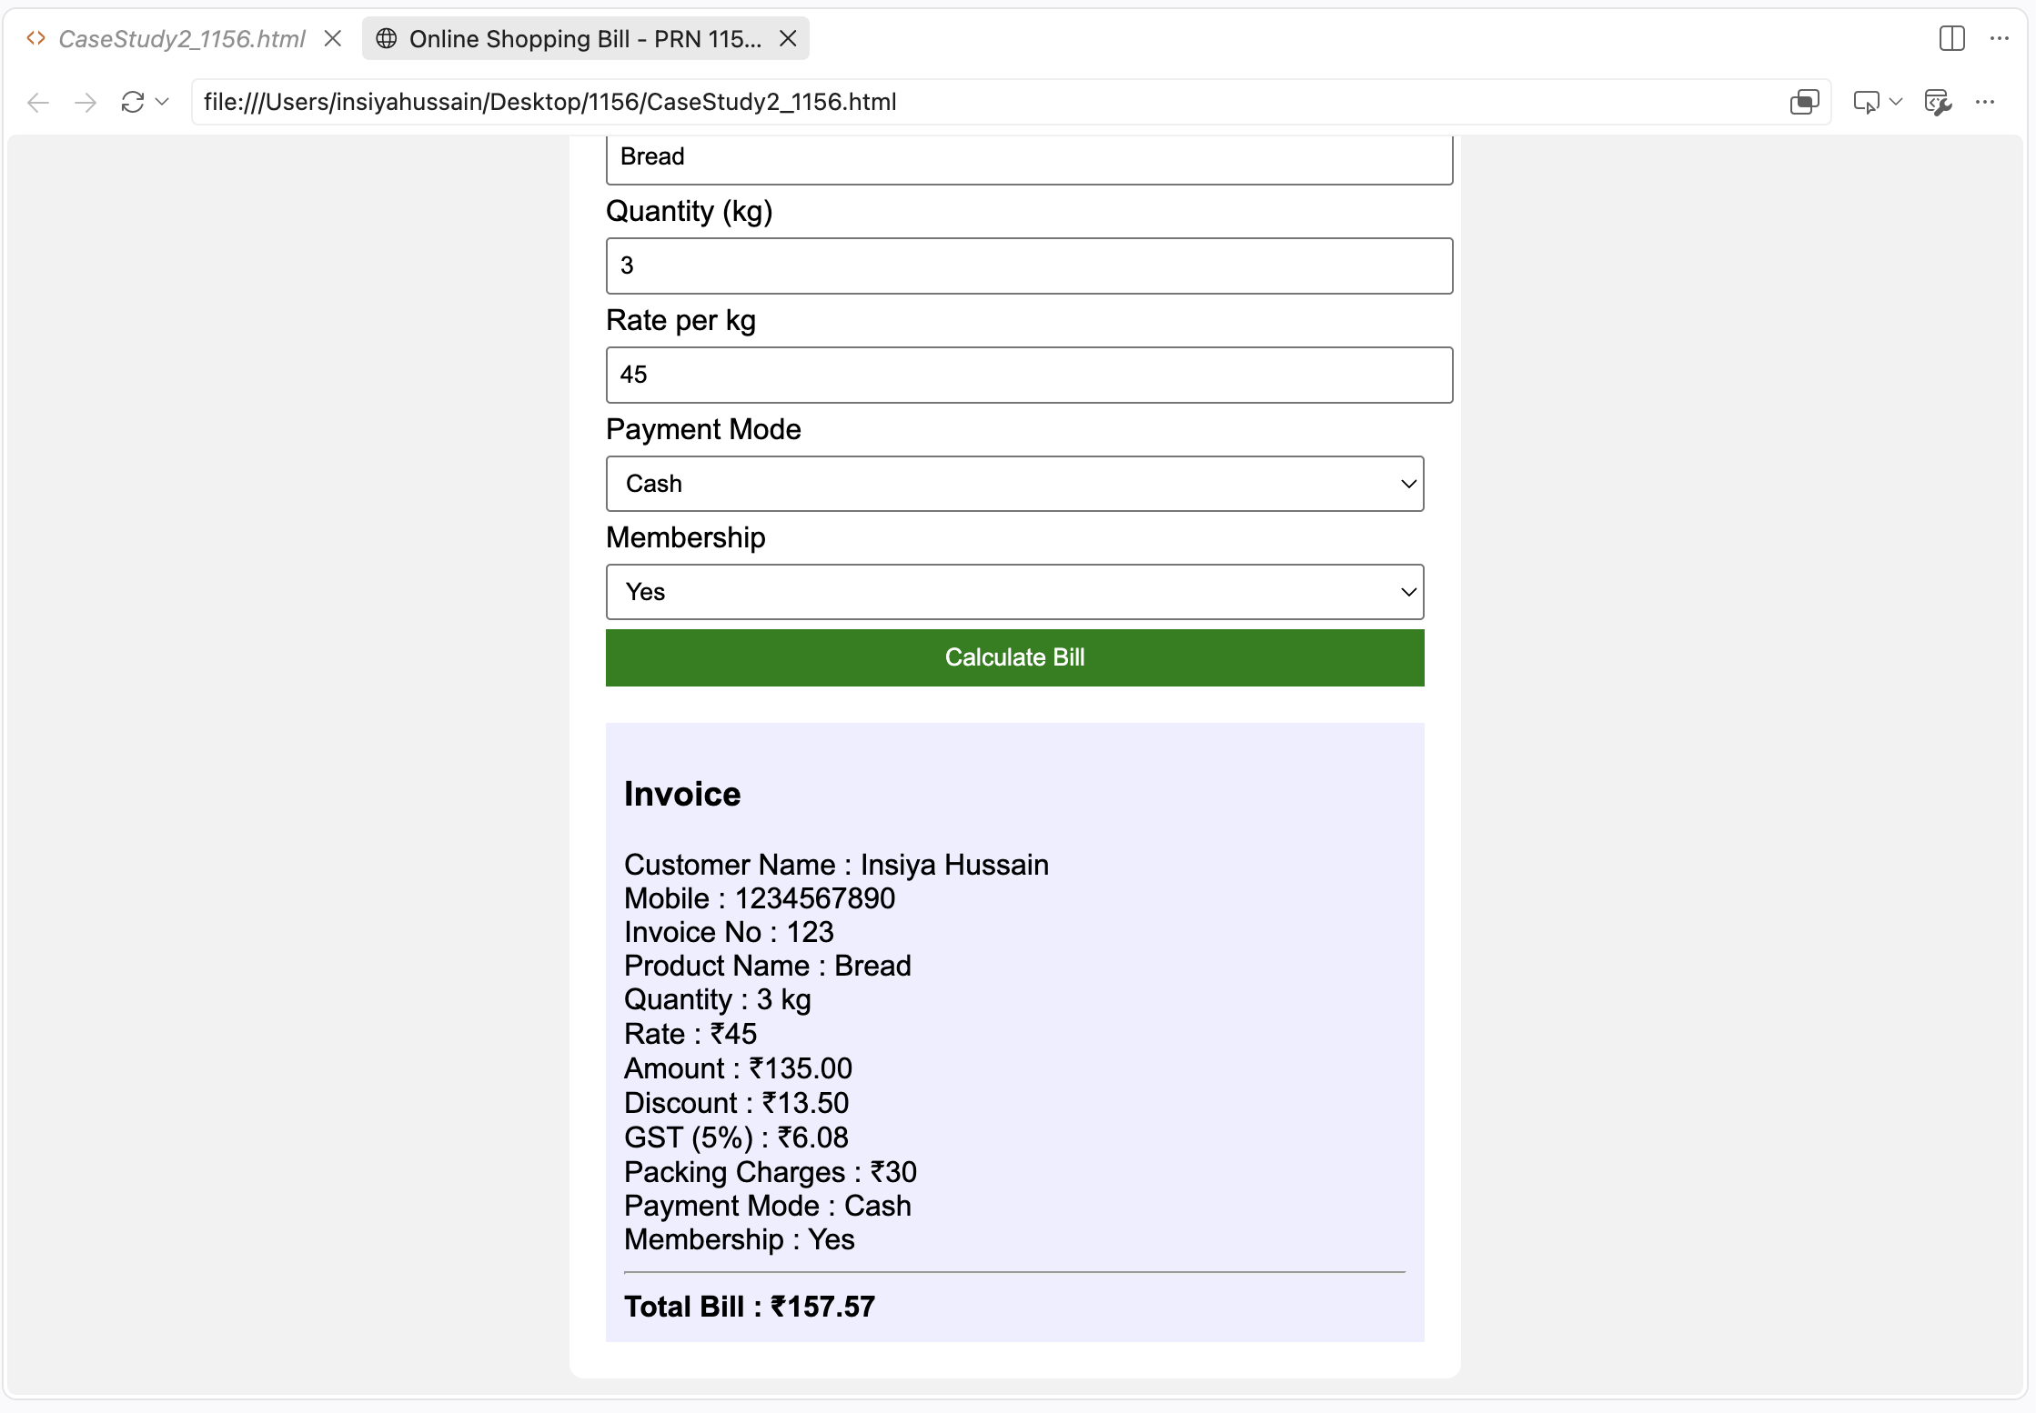

Practical 3
Aim:- Implement control structures and form validation; create a grading system based on user-entered marks.
Software/Tools Required: VS Code , Web Browser
Experiment program code:
<!DOCTYPE html>
<html lang="en">
<head>
<meta charset="UTF-8">
<meta name="viewport" content="width=device-width, initial-scale=1.0">
<title>Student Grading System</title>

<style>
*{
margin:0;
padding:0;
box-sizing:border-box;
font-family:Arial, Helvetica, sans-serif;
}

body{
background:linear-gradient(135deg,#4facfe,#00f2fe);
display:flex;
justify-content:center;
align-items:center;
min-height:100vh;
}

.container{
width:420px;
background:#fff;
padding:30px;
border-radius:15px;
box-shadow:0 10px 25px rgba(0,0,0,0.2);
}

h1{
text-align:center;
color:#0b4f9c;
margin-bottom:5px;
}

p{
text-align:center;
color:#666;
margin-bottom:20px;

font-size:14px;
}

label{
display:block;
margin-top:15px;
font-weight:bold;
color:#333;
}

input{
width:100%;
padding:10px;
margin-top:6px;
border:1px solid #ccc;
border-radius:8px;
font-size:15px;
}

input:focus{
outline:none;
border-color:#0b84ff;
}

button{
width:100%;
padding:12px;
margin-top:25px;
background:#0b84ff;
color:white;
border:none;
border-radius:8px;
font-size:16px;
cursor:pointer;
transition:.3s;
}

button:hover{

background:#0668ca;
}

#result{
display:none;
margin-top:25px;
padding:18px;
border-radius:10px;
background:#eef8ff;
border-left:5px solid #0b84ff;
}

#result h3{

color:#0b4f9c;
margin-bottom:10px;
}

#result p{
text-align:left;
margin:8px 0;
color:#222;
font-size:15px;
}

.footer{
margin-top:20px;
text-align:center;
color:#777;
font-size:13px;
}
</style>

</head>

<body>

<div class="container">

<h1>Student Grading System</h1>
<p>JavaScript Experiment 3</p>

<form id="gradeForm">

<label>Student Name</label>
<input type="text" id="name" placeholder="Enter your name">

<label>Enter Marks (0 - 100)</label>
<input type="number" id="marks" placeholder="Enter marks">

<button type="submit">Generate Result</button>

</form>

<div id="result"></div>

<div class="footer">
<b>Experiment 3</b>
</div>

</div>

<script>
document.getElementById("gradeForm").addEventListener("submit", function(e){

e.preventDefault();

let name=document.getElementById("name").value.trim();
let marks=document.getElementById("marks").value;

if(name==""){
alert("Please enter student name.");
return;
}

if(marks==""){
alert("Please enter marks.");
return;
}

marks=Number(marks);

if(marks<0 || marks>100){
alert("Marks should be between 0 and 100.");
return;
}

let grade,status;

if(marks>=90){
grade="A+";
status="Excellent";
}
else if(marks>=80){
grade="A";
status="Very Good";
}
else if(marks>=70){
grade="B";
status="Good";
}
else if(marks>=60){
grade="C";
status="Average";
}
else if(marks>=50){
grade="D";
status="Pass";
}
else{
grade="F";
status="Fail";
}
document.getElementById("result").style.display="block";

document.getElementById("result").innerHTML=`
<h3>Student Result</h3>

<p><strong>Name :</strong> ${name}</p>

<p><strong>Marks :</strong> ${marks}</p>

<p><strong>Grade :</strong> ${grade}</p>

<p><strong>Status :</strong> ${status}</p>
`;

});

</script>

</body>
</html>

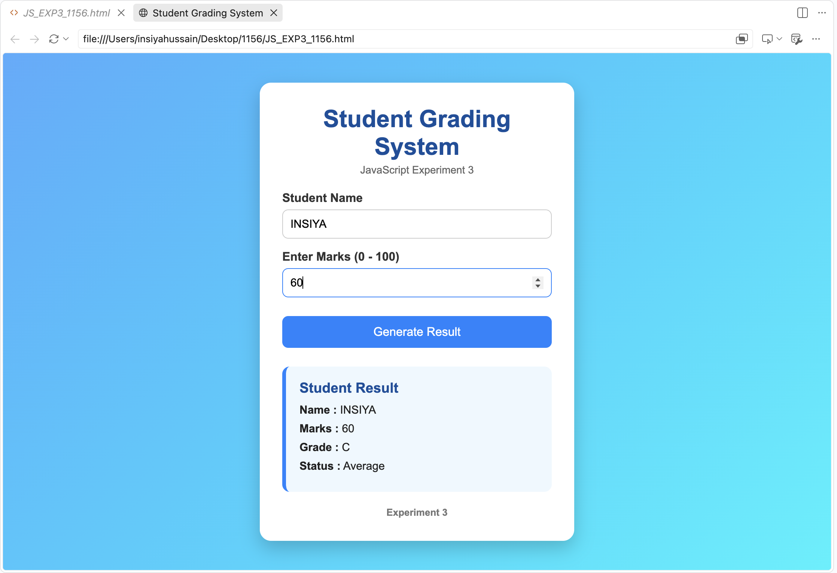
Output:-

Case Study 03
Case Study Title:- Scholarship Eligibilty:
A college awards scholarship based on marks
Below 60:- Not eligible
60-70:- Need-Based Scholarship (25% fee waiver)
70-80:- Merit Scholarship (50% fee waiver)
80-90:- Merit Scholarship (75% fee waiver)
90-100:- Merit Scholarship (100% fee waiver)
Software/Tools Used:- VScode , Web Browser
Case Study Code:-
<!DOCTYPE html>
<html>
<head>
<title>Scholarship Category Program</title>
</head>
<body>

<h2>Student Scholarship Category Checker</h2>

<label>Enter Marks (out of 100): </label>
<input type="number" id="marks">
<button onclick="checkScholarship()">Submit</button>

<p id="result"></p>

<script>
function checkScholarship() {
var marks = Number(document.getElementById("marks").value);
var result = "";

if (marks < 0 || marks > 100) {
result = "Invalid marks. Please enter a value between 0 and 100.";
} else if (marks >= 90) {
result = "Scholarship Category: Merit Scholarship (100% fee waiver)";
} else if (marks >= 80) {
result = "Scholarship Category: Merit Scholarship (75% fee waiver)”;

} else if (marks >= 70) {
result = "Scholarship Category: Merit Scholarship (50% fee waiver)";
} else if (marks >= 60) {
result = "Scholarship Category: Need-Based Scholarship (25% fee waiver)";
} else {
result = "Scholarship Category: Not Eligible for Scholarship";
}

document.getElementById("result").innerHTML = result;
}
</script>

</body>
</html>

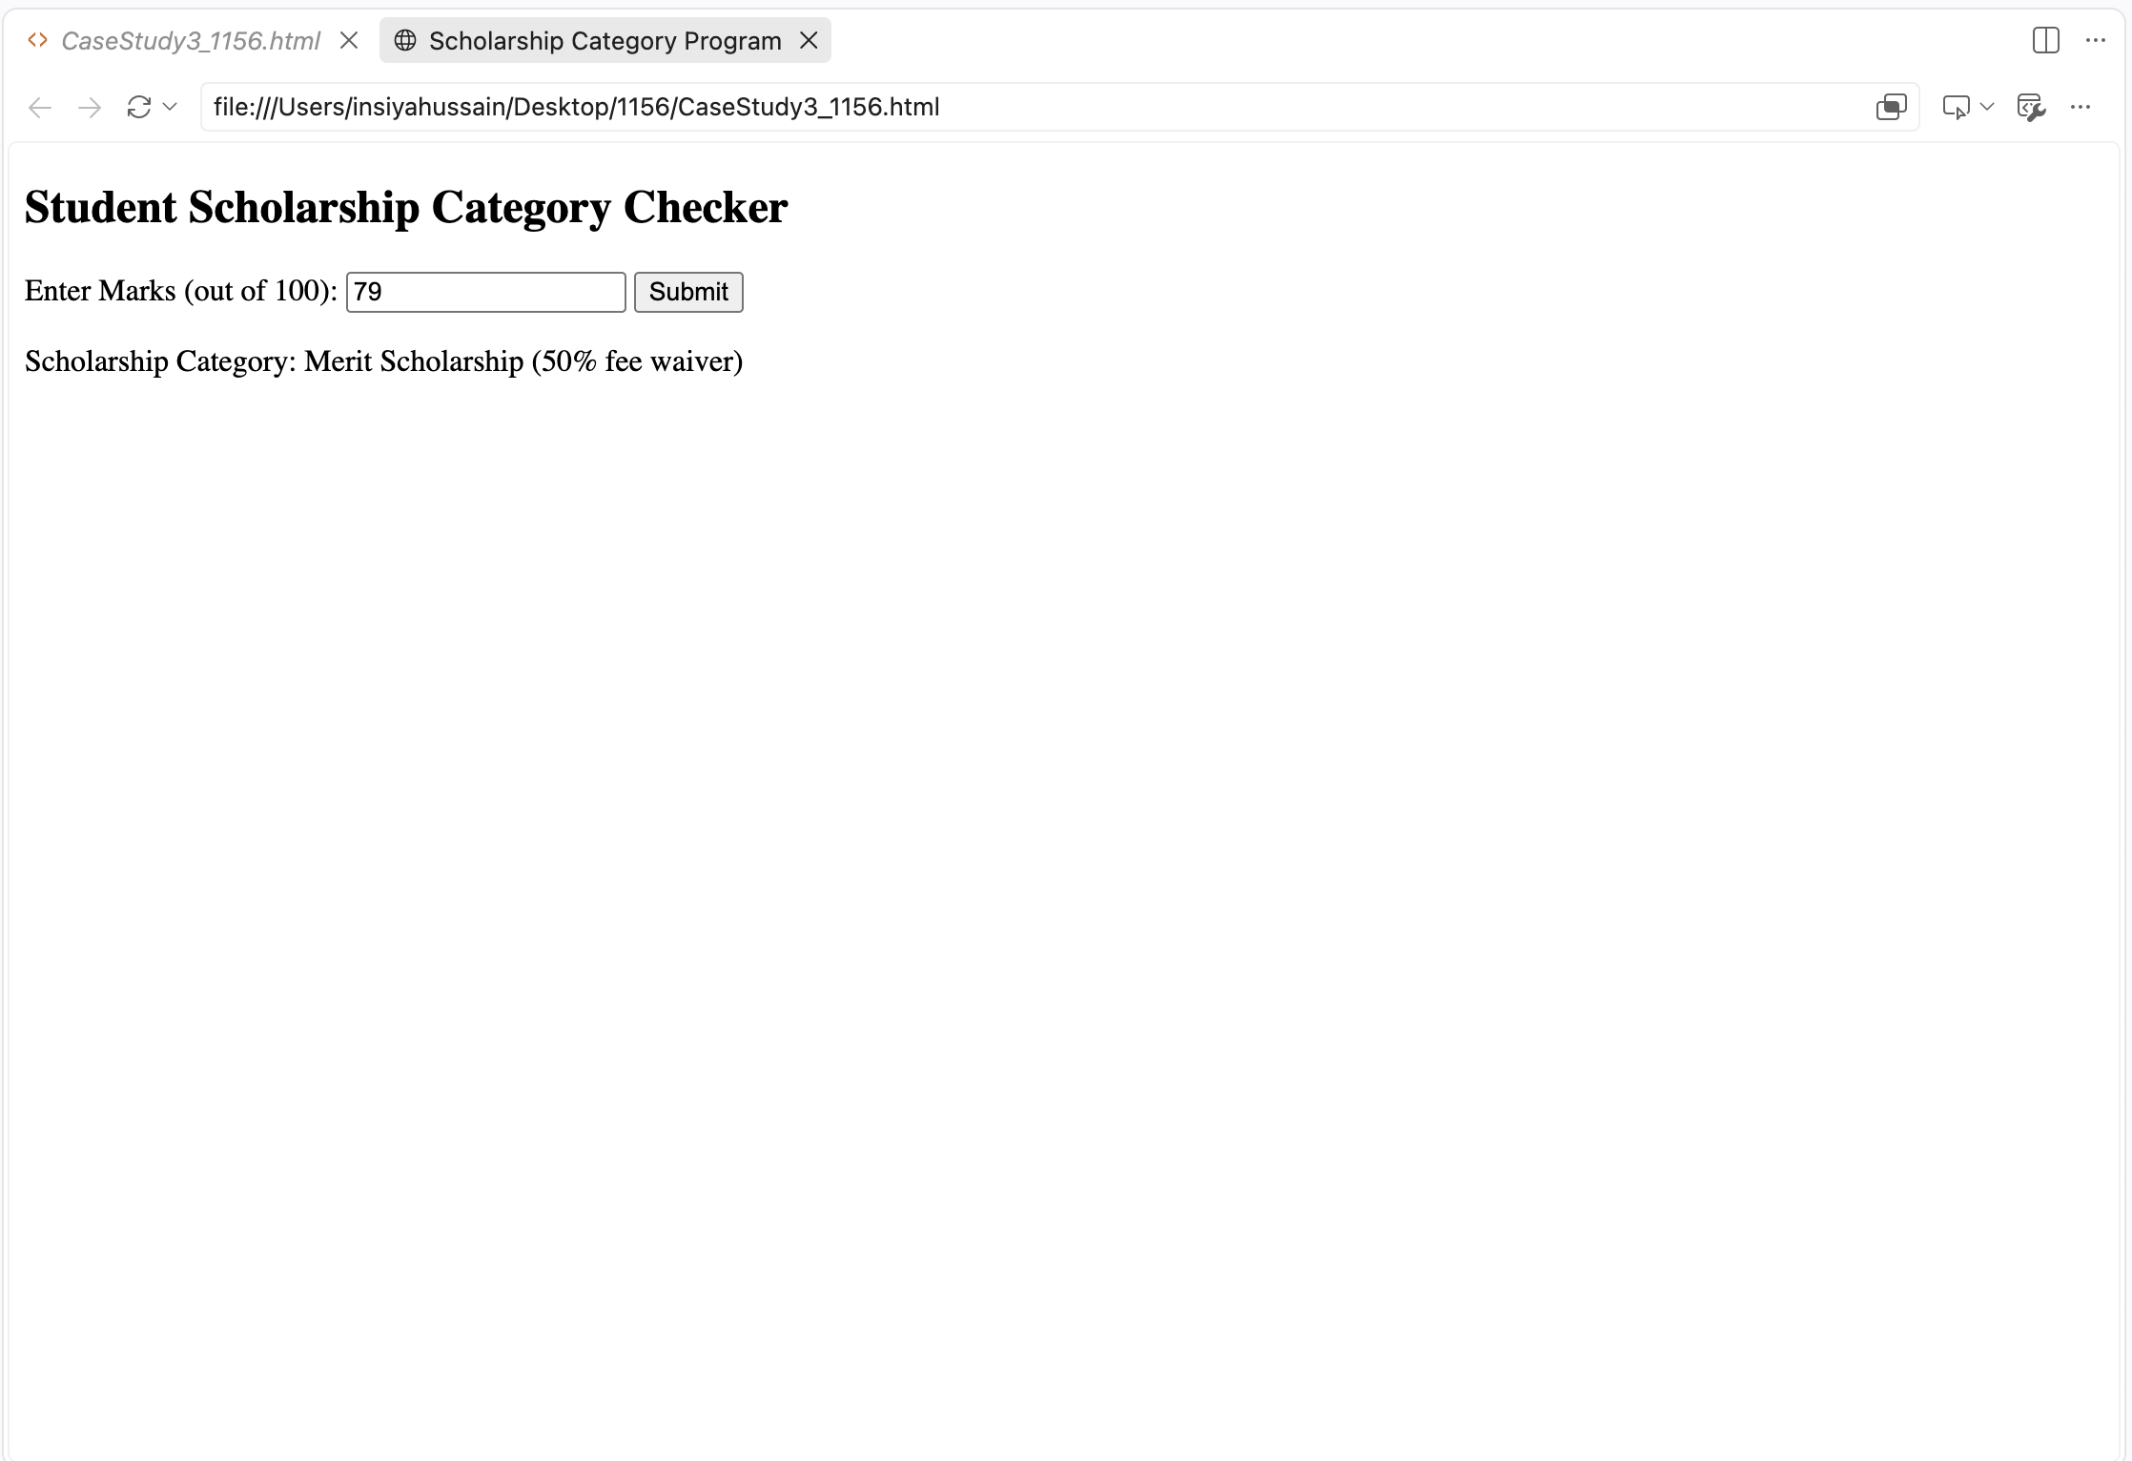
Output:-

Practical 4
Aim:- Use function types ,scope , and closure; apply try catch ;build a palindrome checker
Software/Tools Required: VS Code , Web Browser
Experiment program code:
Palindrome checker:-
// Experiment 4
// Name: INSIYA HUSSAIN
// PRN: 1156
// Title: Function Types, Scope, Closures, Try-Catch & Palindrome Checker

let welcome = function () {
console.log("Palindrome Checker Program.");
};

welcome();

let language = "JavaScript";

function scopeDemo() {
let topic = "Functions";

console.log("Language:", language);
console.log("Topic:", topic);
}

scopeDemo();

function counter() {
let count = 0;

return function () {
count++;
console.log("Counter:", count);
};
}

let c = counter();

c();
c();

function palindrome(word) {

try {

if (!word)
throw "Input cannot be empty";

let reverse = word.split("").reverse().join("");

if (word.toLowerCase() === reverse.toLowerCase())
console.log(word + " is a Palindrome.");
else
console.log(word + " is not a Palindrome.");

}

catch(error) {
console.log("Error:", error);
}

}

palindrome("madam");

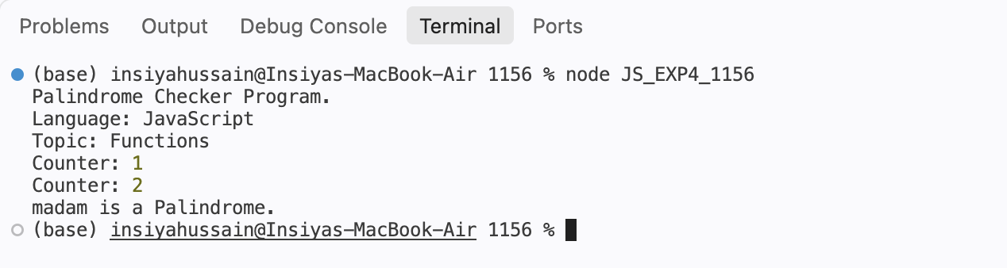
Output:-

Case Study 04
Real-Time Case Study: ATM Card PIN Verification Using JavaScript Functions
Case Study An ATM system verifies whether a customer's PIN is a palindrome. If the PIN reads the same forward and backward, the bank displays a special security message. To implement this, create a function to reverse the entered PIN number and another function to check whether it is a palindrome. Use function declaration, function expression, arrow function, and demonstrate scope concepts
Software/Tools Used:- VScode , Web Browser
Case Study Code:-
// Case Study: ATM Card PIN Verification using JavaScript
// Functions Case Study
// Name: Insiya Hussain
// PRN: 24070521156

// Global Scope: ATM System Configuration

const BANK_NAME = "Global Secure Bank";
const CORRECT_PIN = "1234";
const MAX_ATTEMPTS = 3;

let attempts = 0;

function verifyPin(enteredPin) {
return enteredPin === CORRECT_PIN;
}

const validatePinFormat = function(pin) {
return /^\d{4}$/.test(pin);
};

const generateMessage = (isVerified) => {
if (isVerified) {
return "PIN verified successfully! Welcome to " + BANK_NAME + ".";
} else {
return "Incorrect PIN. Please try again.";
}
};

function processATMVerification(enteredPin) {

console.log("\n------------------------------------");
console.log(" ATM PIN VERIFICATION");
console.log("------------------------------------");
console.log("Bank: " + BANK_NAME);

if (!validatePinFormat(enteredPin)) {
console.log("Invalid PIN. Please enter exactly 4 digits.");
return false;
}

attempts++;

const verified = verifyPin(enteredPin);

const message = generateMessage(verified);

console.log(message);

if (!verified) {
console.log("Attempts remaining: " + (MAX_ATTEMPTS - attempts));
}

return verified;
}

const readline = require("readline");

const rl = readline.createInterface({
input: process.stdin,
output: process.stdout
});

function askForPin() {

if (attempts >= MAX_ATTEMPTS) {
console.log("\nAccount locked. Maximum attempts exceeded.");
rl.close();
return;
}

rl.question("\nEnter your 4-digit ATM PIN: ", function(enteredPin) {

const verified = processATMVerification(enteredPin);

if (verified) {
console.log("\nTransaction can proceed.");
rl.close();
} else if (attempts >= MAX_ATTEMPTS) {
console.log("\nAccount locked. Maximum attempts exceeded.");
rl.close();
} else {
askForPin();
}

});
}
console.log("\n===== WELCOME TO ATM =====");
askForPin();

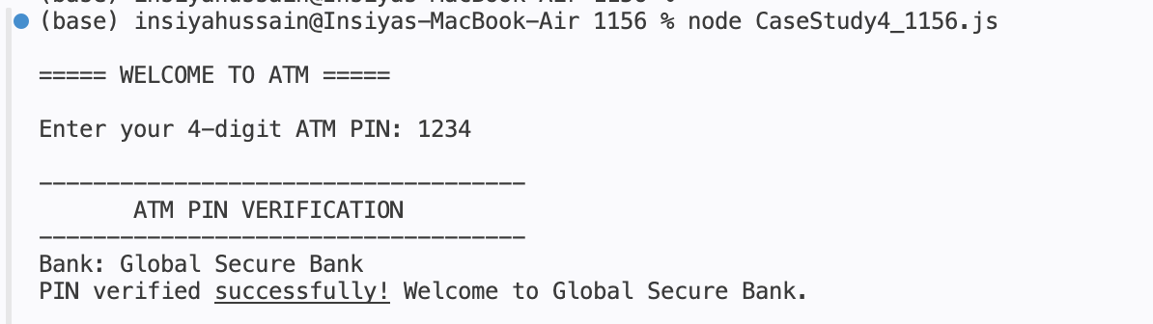
Output:-

